STUDENT Mykhailo Hnylytskyi

FINAL PROJECT REPORT

USER INTERFACES

LECTURER GRAINNE STACK

Contents

Introduction 1

Part 1 1

Personas 1

Persona 1 - Arnold Schwarzenegger (Wikipedia, 2023) 1

Persona 2 - Roman Gosynskyi 2

Persona 3 – Mykola Shevchenko 2

Scenario 2

Persona – 1 2

Persona – 2 2

Persona – 3 3

User Testing 4

Danilo Kramnov 4

Wong, Wang Chung Calvin 5

Filippenko, Phillip 6

Average Scale of app 6

Site Maps and User Flows 7

Site map 7

User Flows 8

URL of updated app 11

Part 2 11

Mockups 11

Created Elements 13

Conclusion 14

References 14

# Introduction

My cinema app is for booking a movie. You log in, choose a film, book a seat for a screening of that film and enjoy. You can also choose any month in this app and book a seat. This idea didn't come to me out of the blue, I was thinking about how to improve booking in Irish cinemas, because you can do it on the website, but I haven't seen an app for that.

# Part 1

## Personas

### Persona 1 - Arnold Schwarzenegger (Wikipedia, 2023)

* 76 years old
* actor, businessman, director, former politician and former professional bodybuilder
* Sometimes uses the Internet
* Uses the Internet exclusively for search purposes
* Has its own website
* Media personality

### Persona 2 - Roman Gosynskyi

* 43 years old
* Famous Ukrainian actor, restaurateur, film producer, film director, screenwriter, singer, composer
* won a Golden Globe in the Best Actor category
* Advanced Internet user
* active Instagram user, has more than 20 million followers
* Very busy person

### Persona 3 – Mykola Shevchenko

* Owner of a Ukrainian football club
* Businessman
* A popular personality at home has a chance to maintain confidentiality
* Use Tik Tok, Instagram, Facebook, X – for the promotion of sports, but all this is done by the marketing team on his behalf
* He has first iPhone, and he believe that this phone is impossible to hack.

## Scenario

### Persona – 1

He loves publicity, but sometimes he wants to watch a film alone with himself. So this app is just for him, he can buy all the seats for the session and sit and watch movies alone or with his family. This app helped him understand the popularity of modern films, because in his time, films were completely different.

### Persona – 2

A perspective, popular actor, a very busy person who doesn't have time to watch films all at once, so he goes to the calendar in the app and chooses a date when he will be free from work.

### Persona – 3

He went all his life, working hard and taking risks to get the success and football team he wanted. Now he can enjoy life with his family in peace and not worry about the future. In this regard, he needs an online cinema ticket booking service where he can book a screening without stressing and continue to drink his cocktail next to his wife while watching the latest movies.

## User Testing

Danilo Kramnov 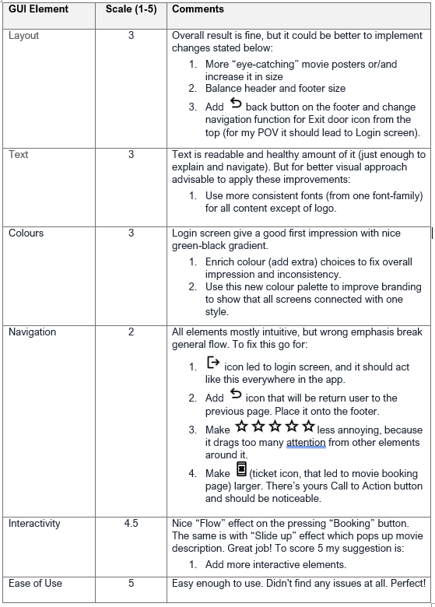

Wong, Wang Chung Calvin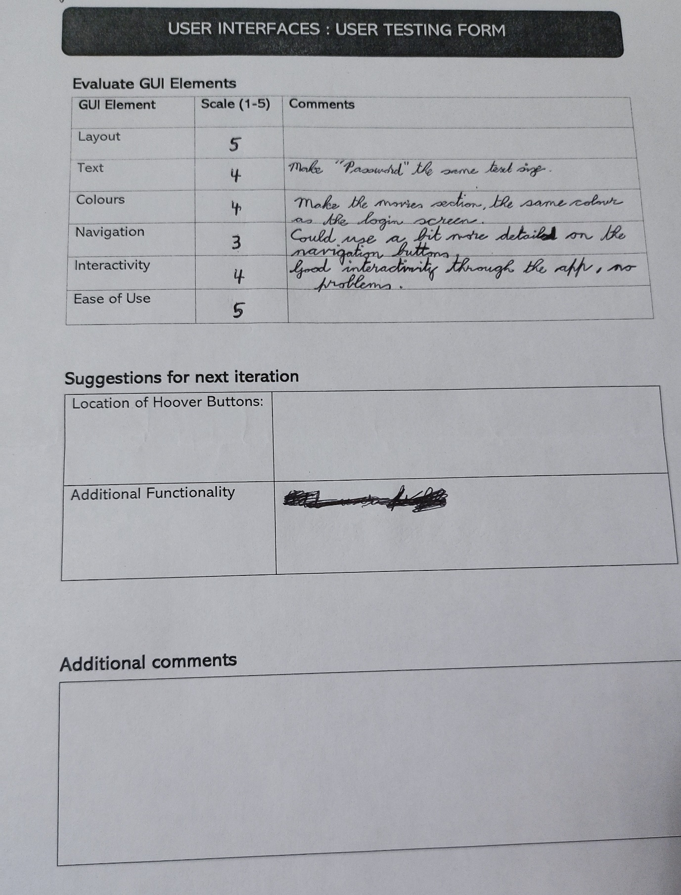

### Filippenko, Phillip

### Average Scale of app

|  |  |
| --- | --- |
| **GUI Element** | **Scale** |
| Layout | 3.8 |
| Text | 3.7 |
| Colours | 3.6 |
| Navigation | 3.16 |
| Interactivity | 4.5 |
| Ease of Use | 5 |

## Site Maps and User Flows

### Site map

### User Flows

**Log in**

Home screen. Log in > Keyboard > Login and next page is introduction page.

**Keyboard**

**Login**

You can delete log in information as well.

Introduction Page. Click on the screen that go to Page 2. Navigation tab go to page 2 and Calendar 1.1.

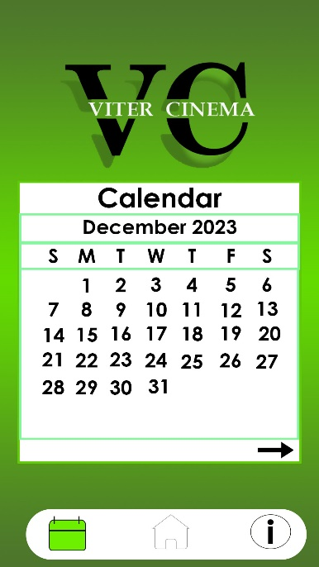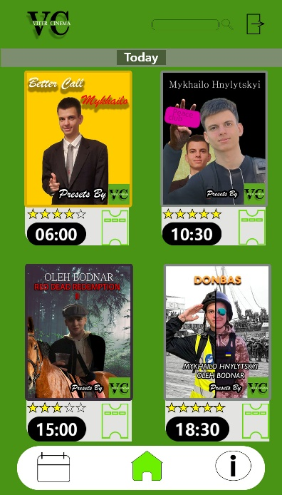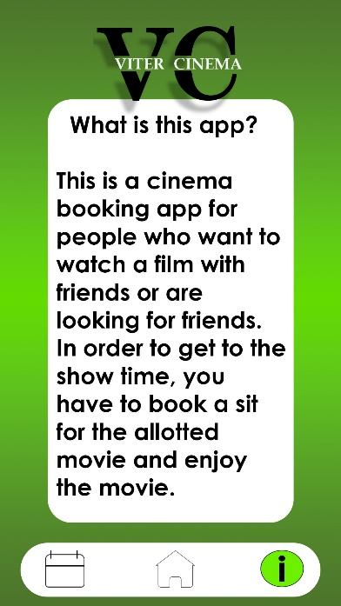

**Introduction Page**

**Calendar 1.1**

**Page 2**

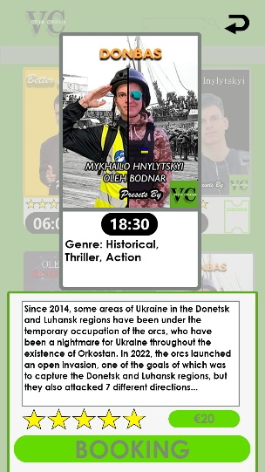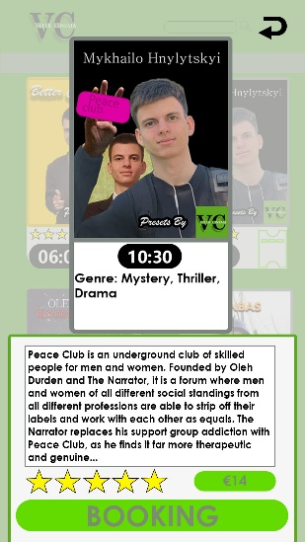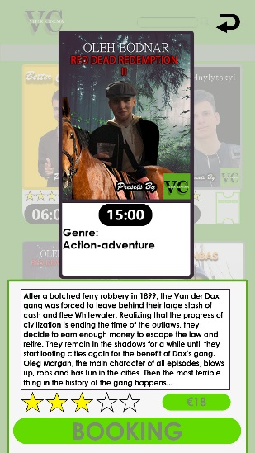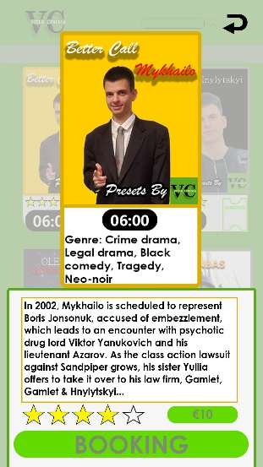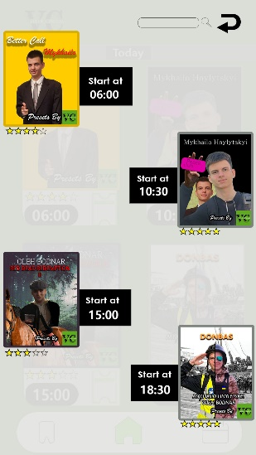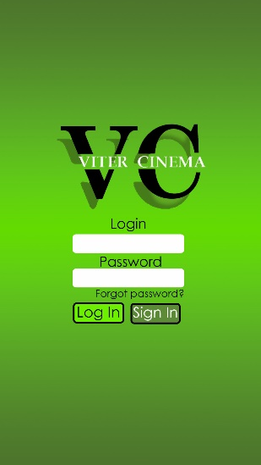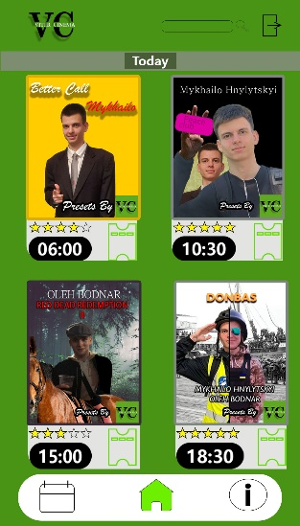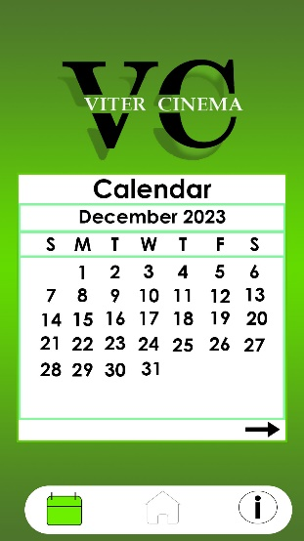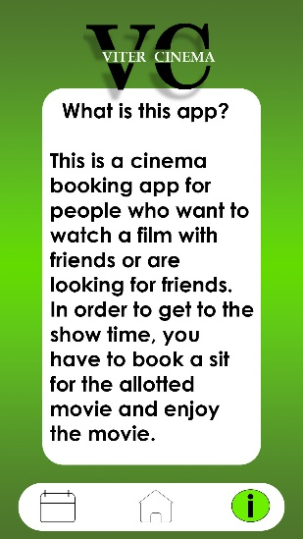Page 2. Page 2 allows you to select a film with the help of Page 3-3.4 and go to Calendar 1.1, Introduction, Search page and exit to Home screen.

**Page 3.4**

**Page 3.2**

**Page 3.3**

**Page 3**

**Search Page**

**Log In**

**Page 2**

**Calendar 1.1**

**Introduction**

From Page 3-3.4 to Page 4-4.4. The changes in pages 3 to 3.4 are different posters, prices and times, and from 4 to 4.4 only the time changes and from these pages you can go to the main page Page 2, so I will attach only the first pages, but you can find other photos in the Mockups section

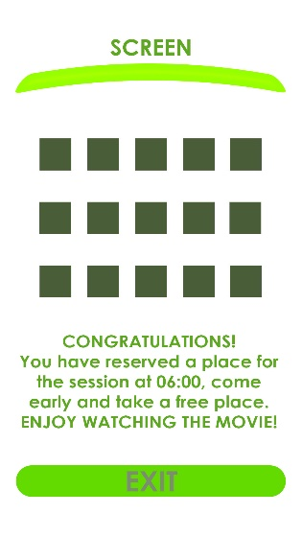

**Page 2**

**Page 4**

**Page 3**

Search Page allow you go to Page 2 and select a movie, for example select first movie.

**Page 2**

**Page 3**

**Search Page**

The calendar page will allow you to select the date that suits you, move to the next or previous month and proceed to page 2 and the introduction. I will attach an example with the choice of December 2023.

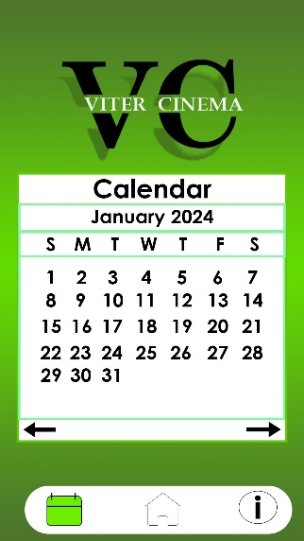

**Calendar**

**Introduction**

**Page 2**

**Calendar 1.1**

## URL of updated app

<https://marvelapp.com/prototype/f4e5agb>

# Part 2

## Mockups

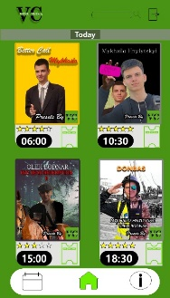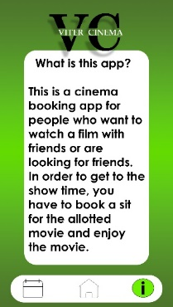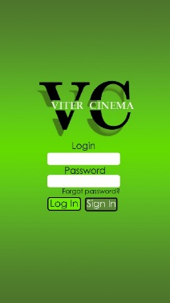

**Page 2**

**Introduction**

**Login**

**Keyboard**

**Log in**

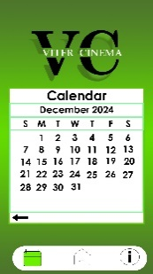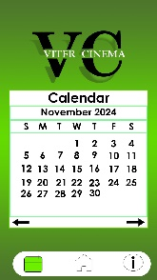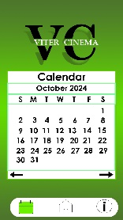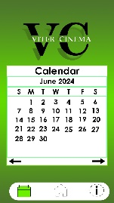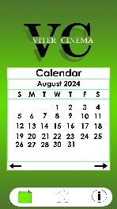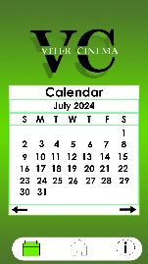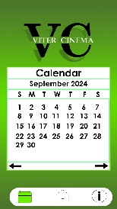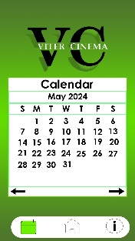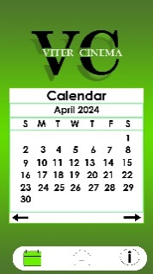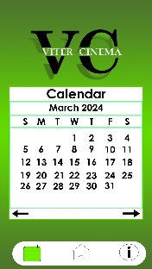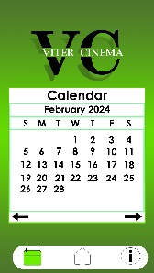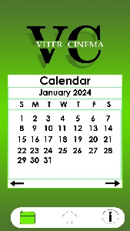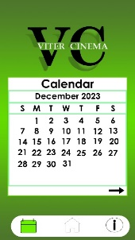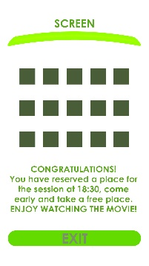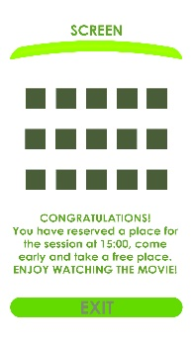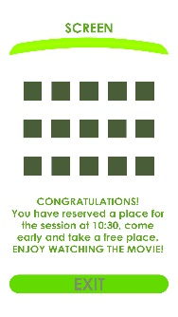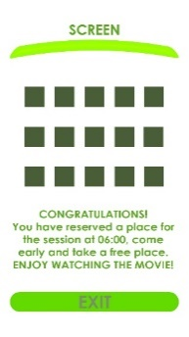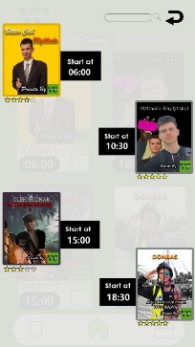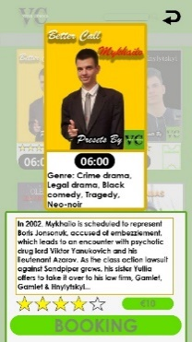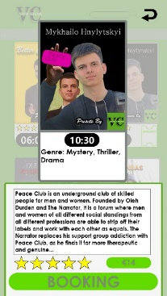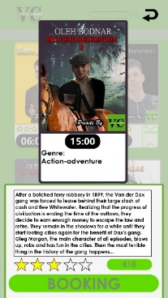

**Calendar 12**

**Calendar 11**

**Calendar 10**

**Calendar 6**

**Calendar 7**

**Calendar 8**

**Calendar 9**

**Calendar 5**

**Calendar 4**

**Calendar 3**

**Calendar 2**

**Calendar**

**Calendar 1.1**

**Page 4.4**

**Page 4.3**

**Page 4.2**

**Page 4**

**Search Page**

**Page 3**

**Page 3.2**

**Page 3.3**

**Page 3.4**

## Created Elements

**Poster 2**

**Poster 1**

**Search element**

**Exit button**

**Logo without background**

**Rating scale**

**Logo**

**Booking tab 2**

**Booking tab 1**

**Booking button**

**Back arrow**

**Forward Arrow**

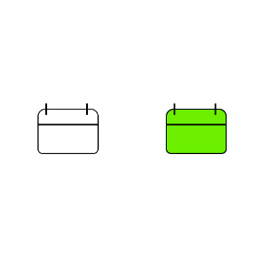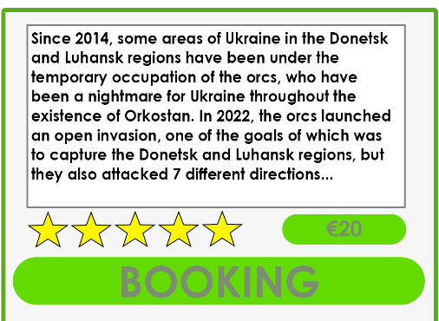

**FAQ button**

**Home button**

**Calendar button**

**Booking tab 4**

**Booking tab 3**

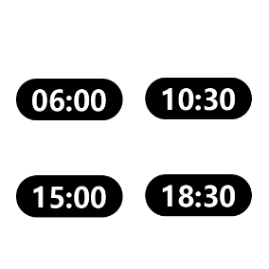

**Time tabs**

**Poster 4**

**Poster 3**

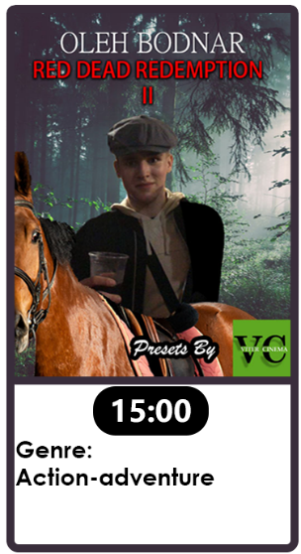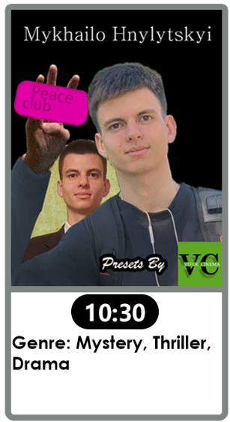

**Poster view 4**

**Poster view 3**

**Poster view 2**

**Poster view 1**

# Conclusion

My app was to create a user-friendly, modern app for all ages. The green colour scheme is the main feature of this app, because it relaxes, is friendly to the user and allows you to take your time to look around. My app has 3 important functions, namely the Home, App Info and Calendar buttons. The bookmarking function takes a few seconds, and watching a new film leaves unforgettable memories. Working on this project has taught me many useful techniques in Photoshop, design, and layout of my work.

# References

Wikipedia, 2023. *Arnold Schwarzenegger.* [Online]   
Available at: https://en.wikipedia.org/wiki/Arnold_Schwarzenegger  
[Accessed 09 12 2023].